The Players Championship

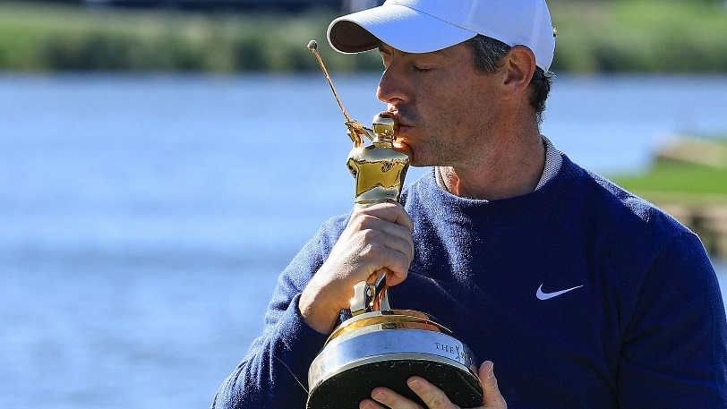
What a tournament! Despite a noticeable lack of Augmented Reality GoldBoy, for the first time in a decade we had a three-hole aggregate playoff (the best kind obviously). JJ Spaun had a chance to win it on Sunday, but left his putt just short, earning the privilege of trying to some sleep on the night before a Monday morning playoff with Rory McIlroy. It went about how you would expect with McIlroy’s victory basically confirmed after Spaun airmailed the island green (technically a peninsula) on the second playoff hole. The win is McIlroy’s third in his past six worldwide starts and he comes into Augusta in better form than ever before. I’m ready to be hurt again.

McIlroy’s win (and subsequent PDA with GoldBoy) was the obvious highlight of James’ league-leading 225-point week, with the rest of his team carding middling results. Wyndham Clark withdrew early on with a neck injury, continuing the nightmare start to his season. Shane Lowry snuck in the top 25 for the fourth time in five starts, and Jake Knapp continued his recent ramp up in form enroute to a top 15. Daniel Berger has been on an exceptional hot streak lately, but couldn’t crack the top 15, making James’ Konkel use less than ideal.

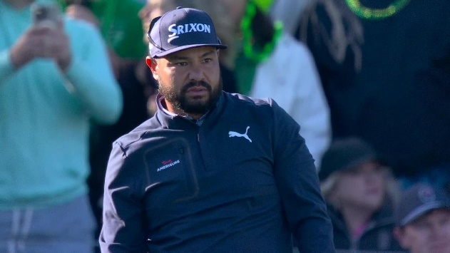
Bryce is up to seven 100+ point weeks out of 11 now, as he continues his exceptionally hot start, opening up a significant lead. This week his 160 points even came with a monster 70 left on the bench courtesy of Tom Hoge. Despite the missed opportunity, he carded two more top tens, including Spaun’s second place. Collin Morikawa is off to a great start in 2025, despite the fact that he’s allergic to winning, and it was another top ten for him this week. I have not a single regret in life, save advising Beast to move on from Sepp Straka. Another top 15 this week, and another dagger right through the heart of our league’s eldest member.

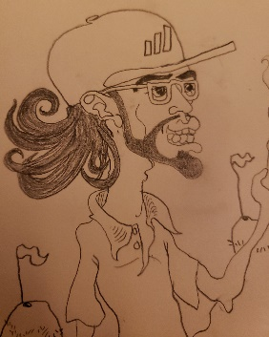
Speaking of Beast, it wasn’t all suffering for him this week. His top picks continue to deliver where his keepers haven’t, with Bhatia, Rai, and Jaeger combining for all of his 115 points. Bhatia in particular was in the lead at one point, before falling back on Saturday. A solid 70 on Sunday was good for a third place finish. Beast will be hoping that Bhatia can deliver on his promise, as both Jordan Spieth and Sungjae Im have disappointed so far in 2025.

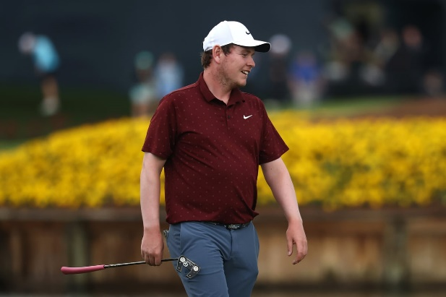
It's been a tough season for Kevan so far in their quest for a three-peat, cracking the 100 point mark just once at the Genesis Invitational. This week matched their second highest total of the year at 95 points. Scheffler was serving up missed putts ‘Scottie-style’ all week, but still cracked the top 25 since it’s impossible for him not to. Big Shot Bob MacIntyre and Denny McCarthy have both had solid starts to the season, and that continued this week with a top ten and top fifteen respectively. Sahith Theegala has been lost in the woods this year, posting his fifth goose egg this week. They’re still hanging around the log jam from 3rd to 6th, and one big week from Scottie is all they need to find them back in the thick of it.
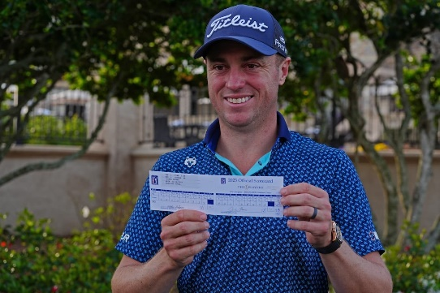
Mrs. Beast wants to get off Mr. Thomas’ Wild Ride, with JT rubber-banding from 78 to 62 to start the week. Unfortunately he bounced back up to a pair of 73s on the weekend and couldn’t crack the top 25. Big things (other than a win) are always expected from Tommy Fleetwood, and he didn’t disappoint this week with a solid top fifteen. Don’t look now, but Russell Henley is at seventh in the Official World Golf Rankings, ahead of Fleetwood, JT, Wyndham Clark, and Patrick Cantlay. Is that sustainable? Who knows, but Mrs. Beast isn’t complaining.
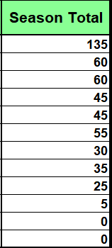
Seumas, Daniel, and Jon Mark all posted 50s this week, thanks to Corey Conners, Cantlay, and Davis Thompson respectively. It would be remiss of me to not shout out Seumas’ use of a Konkel on Ludvig this week, just a few weeks ahead of the Masters where he finished T2 last year in his first Major start. Could that cost him down the road? Speaking of money, Xander Schauffele hasn’t been making much of it this year, making just three starts because of injury, and carding just 10 total points. Like someone else we’ll be talking about later in this wrap up, Jon Mark has gotten diddly squat from his keepers, and will need them to step up if he wants back in the fray. Daniel is going full Racko, as his player’s total points are remarkably almost perfectly in order from most to least. It’s quite beautiful actually.


Tough week on the links for Lawrence, with Min Woo Lee in contention on Saturday before ejecting himself to a top 25. Keegan Bradley’s top 25 will probably feel better, as he keeps himself in the hunt for a playing Ryder Cup captaincy. Other than that it was zeroes across the board for Lawrence. He’s still in the middle of the pack and has a roster that should play well at Augusta, if he can get through this run of his dreaded Tier 1s.

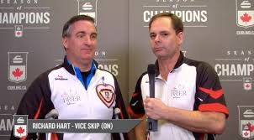
Ah Brent. Much like Richard Hart’s foray into broadcasting, this is hard to watch. Five weeks in a row now without a top ten, and an abhorrent 1.6 points per week from his formerly elite keepers, Brent may have gone gently into that good night. Should a comeback issue from the ashes of this once great monument to athletic adroitness, it would surely be a transcendental consummation of the highest order.

